**IOT_phase1**

**Project Definition:**

* System uses air sensors to sense presence of harmful gases/compounds in the air and constantly transmit this data to microcontroller. Also system keeps measuring sound level and reports it to the online server over IOT. The sensors interact with microcontroller which processes this data and transmits it over internet.
* Noise pollution impacts millions of people on a daily basis. The most common health problem it causes is (NIHL). Exposure to loud noise can also cause high blood pressure, heart disease, sleep disturbances, and stress.

**Goals:**

* Noise pollution, also known as environmental noise or sound pollution, is the propagation of noise with harmful impact on the activity of human or animal life. Objectives: To regulate and control noise producing and generating sources. Maintaining the ambient air quality standards in respect of noise.
* This allows authorities to monitor air pollution in different areas and take action against it. Also authorities can keep a watch on the noise pollution near schools, hospitals and no honking areas, and if system detects air quality and noise issues it alerts authorities so they can take measures to control the issue.

**Project Objectives:**

The core objective of this noise pollution monitoring project is to address the pervasive issue of noise pollution in urban environments by deploying state-of-the-art IoT sensors to gather real-time noise level data across various public areas. Through the development of an accessible and user-friendly noise pollution information platform or mobile application, the project aims to bridge the gap between data collection and public awareness. By processing and visualizing this data using tools like Python, it enables individuals and communities to make data-driven decisions regarding noise exposure, facilitating the identification of noise pollution trends and areas requiring mitigation efforts. Additionally, the project strives to promote active engagement within the community, fostering a collective commitment to noise reduction and improved urban living conditions through education and awareness initiatives.

**Problem Solving :**

To reduce the noise pollution from industrial area the use of IOT technique is presented in this paper. Using the noise sensors, the noise intensity is determined at that area and processed this signal and transferred it to the microcontroller.

System keeps measuring sound level and reports it to the online server over IOT. The sensors interact with microcontroller which processes this data and transmits it over internet. This allows authorities to monitor air pollution in different areas and take action against it.

Block Daigram:

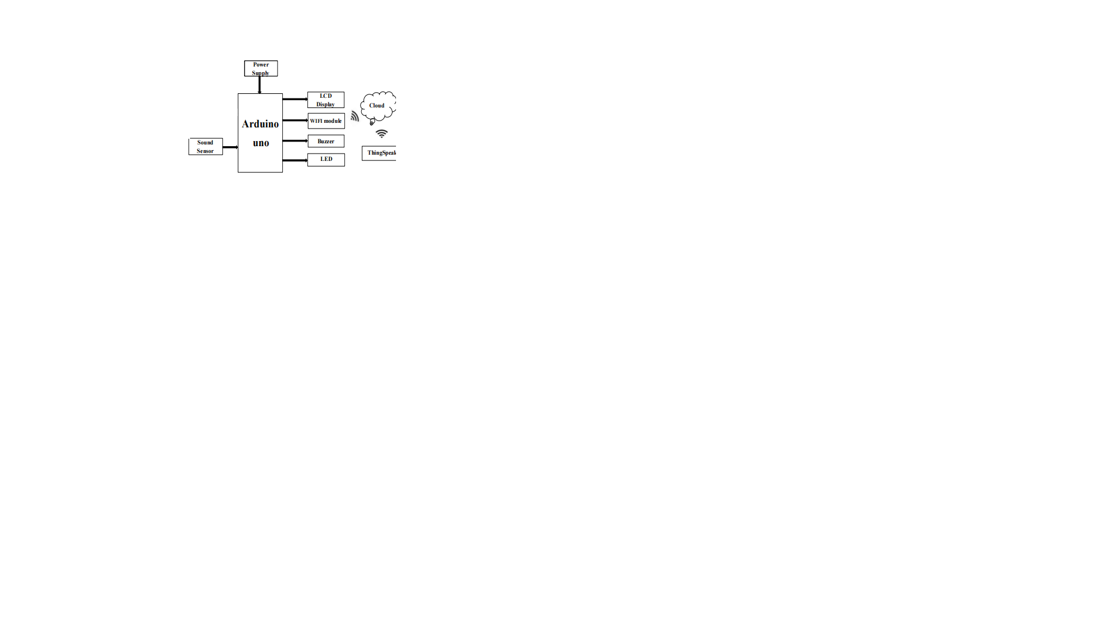

Algorithm:

1.Start Arduino UNO.

2. initialize LCD, gas sensor & noise sensor

3. Establish WITI connections.

4. If connection successful. next step else go to step 1

5. Read sensor values.

6. If Sensor value available establish TCP connection

else read values again.

7. Establish TCP connection

8. If TCP connections successful. send data to server

(Thingspeak). else set go to step 7

9. If TCP connections successful. send data to server

(ThingSpeak). else set gob to step 7

10. Check for acknowledgement.

11. If acknowledgement received. go to step some time

& else wait for go to step no 5.